1. 1) S17 - DOM to Selenium Code
DOM to Selenium Code Give the DOM as input Leaftaps login and generate the playwright typescript /Selenium Java or any thing of your choice
with Different models using temperature
Postman Request:
{
"messages": [
{
"role": "user",
"content": "Extract the below given DOM : \n\n<input type=\"text\" class=\"inputBox\" name=\"companyName\" size=\"30\" maxlength=\"100\" id=\"createLeadForm_companyName\">\n<input type=\"text\" class=\"inputBox\" name=\"lastName\" size=\"30\" maxlength=\"100\" id=\"createLeadForm_lastName\">\n<input type=\"text\" class=\"inputBox\" name=\"firstName\" size=\"30\" maxlength=\"100\" id=\"createLeadForm_firstName\">\n<input type=\"submit\" class=\"smallSubmit\" name=\"submitButton\" value=\"Create Lead\" id=\"ext-gen630\"> and provide me the selenium java code. Instructions: Do not use ID if the value has number in it. Provide only java code and no explanations needed"
}
],
"model": "meta-llama/llama-4-scout-17b-16e-instruct",
"temperature": 0.1
}

Postman Reponse:
{
"id": "chatcmpl-f410ee85-4e7e-4319-82df-89c19a2d09cc",
"object": "chat.completion",
"created": 1769105543,
"model": "meta-llama/llama-4-scout-17b-16e-instruct",
"choices": [
{
"index": 0,
"message": {
"role": "assistant",
"content": "```java\nimport org.openqa.selenium.By;\nimport org.openqa.selenium.WebDriver;\nimport org.openqa.selenium.WebElement;\nimport org.openqa.selenium.chrome.ChromeDriver;\n\npublic class Main {\n public static void main(String[] args) {\n System.setProperty(\"webdriver.chrome.driver\", \"/path/to/chromedriver\");\n WebDriver driver = new ChromeDriver();\n driver.get(\"your_website_url\");\n\n WebElement companyNameInput = driver.findElement(By.name(\"companyName\"));\n WebElement lastNameInput = driver.findElement(By.name(\"lastName\"));\n WebElement firstNameInput = driver.findElement(By.name(\"firstName\"));\n WebElement submitButton = driver.findElement(By.className(\"smallSubmit\"));\n\n companyNameInput.sendKeys(\"Company Name\");\n lastNameInput.sendKeys(\"Last Name\");\n firstNameInput.sendKeys(\"First Name\");\n submitButton.click();\n }\n}\n```"
},
"logprobs": null,
"finish_reason": "stop"
}
],
"usage": {
"queue_time": 0.074543471,
"prompt_tokens": 166,
"prompt_time": 0.005669608,
"completion_tokens": 183,
"completion_time": 0.458490062,
"total_tokens": 349,
"total_time": 0.46415967
},
"usage_breakdown": null,
"system_fingerprint": "fp_79da0e0073",
"x_groq": {
"id": "req_01kfkegkkgej88ydsdrfqb1y56",
"seed": 1486482736
},
"service_tier": "on_demand"
}
Example : 2
{
"messages": [
{
"role": "user",
"content": "Extract the below given DOM : \n\n<input type=\"text\" class=\"inputBox\" name=\"companyName\" size=\"30\" maxlength=\"100\" id=\"createLeadForm_companyName\">\n<input type=\"text\" class=\"inputBox\" name=\"lastName\" size=\"30\" maxlength=\"100\" id=\"createLeadForm_lastName\">\n<input type=\"text\" class=\"inputBox\" name=\"firstName\" size=\"30\" maxlength=\"100\" id=\"createLeadForm_firstName\">\n<input type=\"submit\" class=\"smallSubmit\" name=\"submitButton\" value=\"Create Lead\" id=\"ext-gen630\"> and provide me the playwrite code. Instructions: Do not use ID if the value has number in it. Provide only playwrite code and no explanations needed"
}
],
"model": "openai/gpt-oss-120b",
"temperature": 0.1
}

{
"id": "chatcmpl-2901489d-ba11-4709-a6ef-2995d411b094",
"object": "chat.completion",
"created": 1769106037,
"model": "openai/gpt-oss-120b",
"choices": [
{
"index": 0,
"message": {
"role": "assistant",
"content": "```javascript\nconst { chromium } = require('playwright');\n\n(async () => {\n const browser = await chromium.launch({ headless: true });\n const page = await browser.newPage();\n\n // Navigate to the target page\n await page.goto('https://example.com/your-form-page');\n\n // Fill the form fields\n await page.fill('input[name=\"companyName\"]', 'Acme Corp');\n await page.fill('input[name=\"lastName\"]', 'Doe');\n await page.fill('input[name=\"firstName\"]', 'John');\n\n // Submit the form without using an ID that contains numbers\n await page.click('input[type=\"submit\"][value=\"Create Lead\"]');\n\n await browser.close();\n})();\n```",
"reasoning": "We need to output Playwright code to extract the given DOM? Likely they want selectors to interact with these inputs without using IDs that contain numbers. So use other attributes like name, class, placeholder? Provide code that fills fields and clicks submit. Use Playwright test or script. Provide only code, no explanations.\n\nWe must not use ID if the value has number in it. IDs have numbers: createLeadForm_companyName (no number), createLeadForm_lastName (no number), createLeadForm_firstName (no number), ext-gen630 (has number). So we should avoid using ID for the submit button. Use other selectors like text, role, or attribute.\n\nProvide code:\n\nconst { chromium } = require('playwright');\n\n(async () => {\n const browser = await chromium.launch();\n const page = await browser.newPage();\n await page.goto('URL');\n\n await page.fill('input[name=\"companyName\"]', 'Acme Corp');\n await page.fill('input[name=\"lastName\"]', 'Doe');\n await page.fill('input[name=\"firstName\"]', 'John');\n await page.click('input[type=\"submit\"][value=\"Create Lead\"]');\n\n await browser.close();\n})();\n\nThat's fine. Provide only code."
},
"logprobs": null,
"finish_reason": "stop"
}
],
"usage": {
"queue_time": 0.049675281,
"prompt_tokens": 229,
"prompt_time": 0.008719739,
"completion_tokens": 416,
"completion_time": 0.884489512,
"total_tokens": 645,
"total_time": 0.893209251,
"completion_tokens_details": {
"reasoning_tokens": 256
}
},
"usage_breakdown": null,
"system_fingerprint": "fp_8a618bed98",
"x_groq": {
"id": "req_01kfkeznmjfjj9k4z2tvpt5ybf",
"seed": 806128163
},
"service_tier": "on_demand"
}
2. S21 - MultiLingual
Ask to generate any content in diff languages (Japanese,Tamil,Telugu of your choice) and check whether the ouput is correct .
Request:
{
"model": "moonshotai/kimi-k2-instruct-0905",
"messages": [
{
"role": "system",
"content": "You are a professional translator."
},
{
"role": "user",
"content": "Translate the following test instructions into sanskrit and tamil: 'Open the application, enter the credentials, and click on the login button.'"
}
],
"temperature": 0.3
}

Response:
{
"id": "chatcmpl-cc15f192-355c-4621-b64d-dd02cc21ed52",
"object": "chat.completion",
"created": 1769106125,
"model": "moonshotai/kimi-k2-instruct-0905",
"choices": [
{
"index": 0,
"message": {
"role": "assistant",
"content": "Sanskrit \nउद्घाटय अनुप्रयोगम्, प्रत्ययपत्राणि प्रविश्य, प्रवेशबटनं क्लिक कुरु। \n\nTamil \nபயன்பாட்டைத் திறந்து, அடையாளத் தகவல்களை உள்ளிட்டு, உள்நுழைவு பொத்தானைச் சொடுக்கவும்."
},
"logprobs": null,
"finish_reason": "stop"
}
],
"usage": {
"queue_time": 0.283265432,
"prompt_tokens": 46,
"prompt_time": 0.011200548,
"completion_tokens": 110,
"completion_time": 0.552154273,
"total_tokens": 156,
"total_time": 0.563354821
},
"usage_breakdown": null,
"system_fingerprint": "fp_05df423bab",
"x_groq": {
"id": "req_01kfkf2bzpf5xbbv2d5pmwzh2n",
"seed": 951661866
},
"service_tier": "on_demand"
}
Example :2
request:
{
"model": "moonshotai/kimi-k2-instruct",
"messages": [
{
"role": "system",
"content": "You are a professional translator."
},
{
"role": "user",
"content": "Translate the following test instructions into hindi and arab: 'Open the application, enter the credentials, and click on the login button.'"
}
],
"temperature": 0.3
}

Response:
{
"id": "chatcmpl-71db1637-f931-4ebe-bec2-a2f79d9391de",
"object": "chat.completion",
"created": 1769106325,
"model": "moonshotai/kimi-k2-instruct",
"choices": [
{
"index": 0,
"message": {
"role": "assistant",
"content": "**Hindi:** \nएप्लिकेशन खोलें, क्रेडेंशियल्स दर्ज करें, और लॉगिन बटन पर क्लिक करें।\n\n**Arabic:** \nافتح التطبيق، أدخل بيانات الاعتماد، ثم انقر على زر تسجيل الدخول."
},
"logprobs": null,
"finish_reason": "stop"
}
],
"usage": {
"queue_time": 0.283566875,
"prompt_tokens": 43,
"prompt_time": 0.010728884,
"completion_tokens": 84,
"completion_time": 0.258291662,
"total_tokens": 127,
"total_time": 0.269020546
},
"usage_breakdown": null,
"system_fingerprint": "fp_05df423bab",
"x_groq": {
"id": "req_01kfkf8fe8fbvrpd2nck49snek",
"seed": 727796697
},
"service_tier": "on_demand"
}
3)S16-Transcriptions
Try to generate the meeting summary of your office meeting or any files of your choice and Extract the text
(Use whisper-large-v3 and also the whisper-large-v3 Turbo)
1. whisper-large-v3
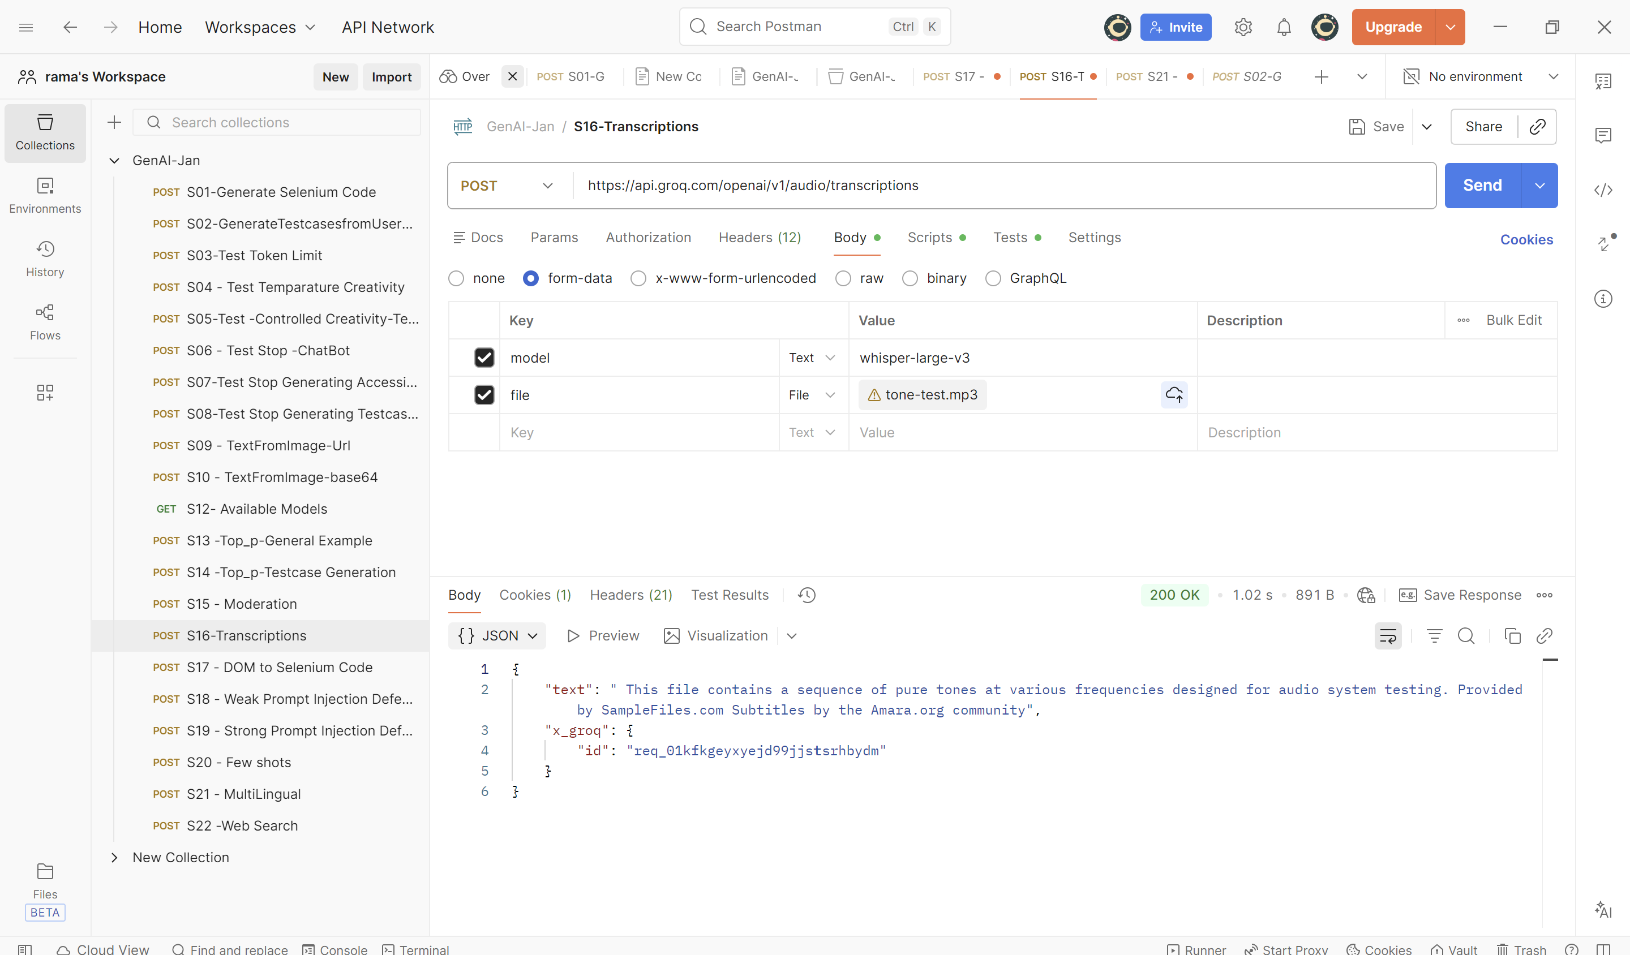

2.whisper-large-v3 Turbo
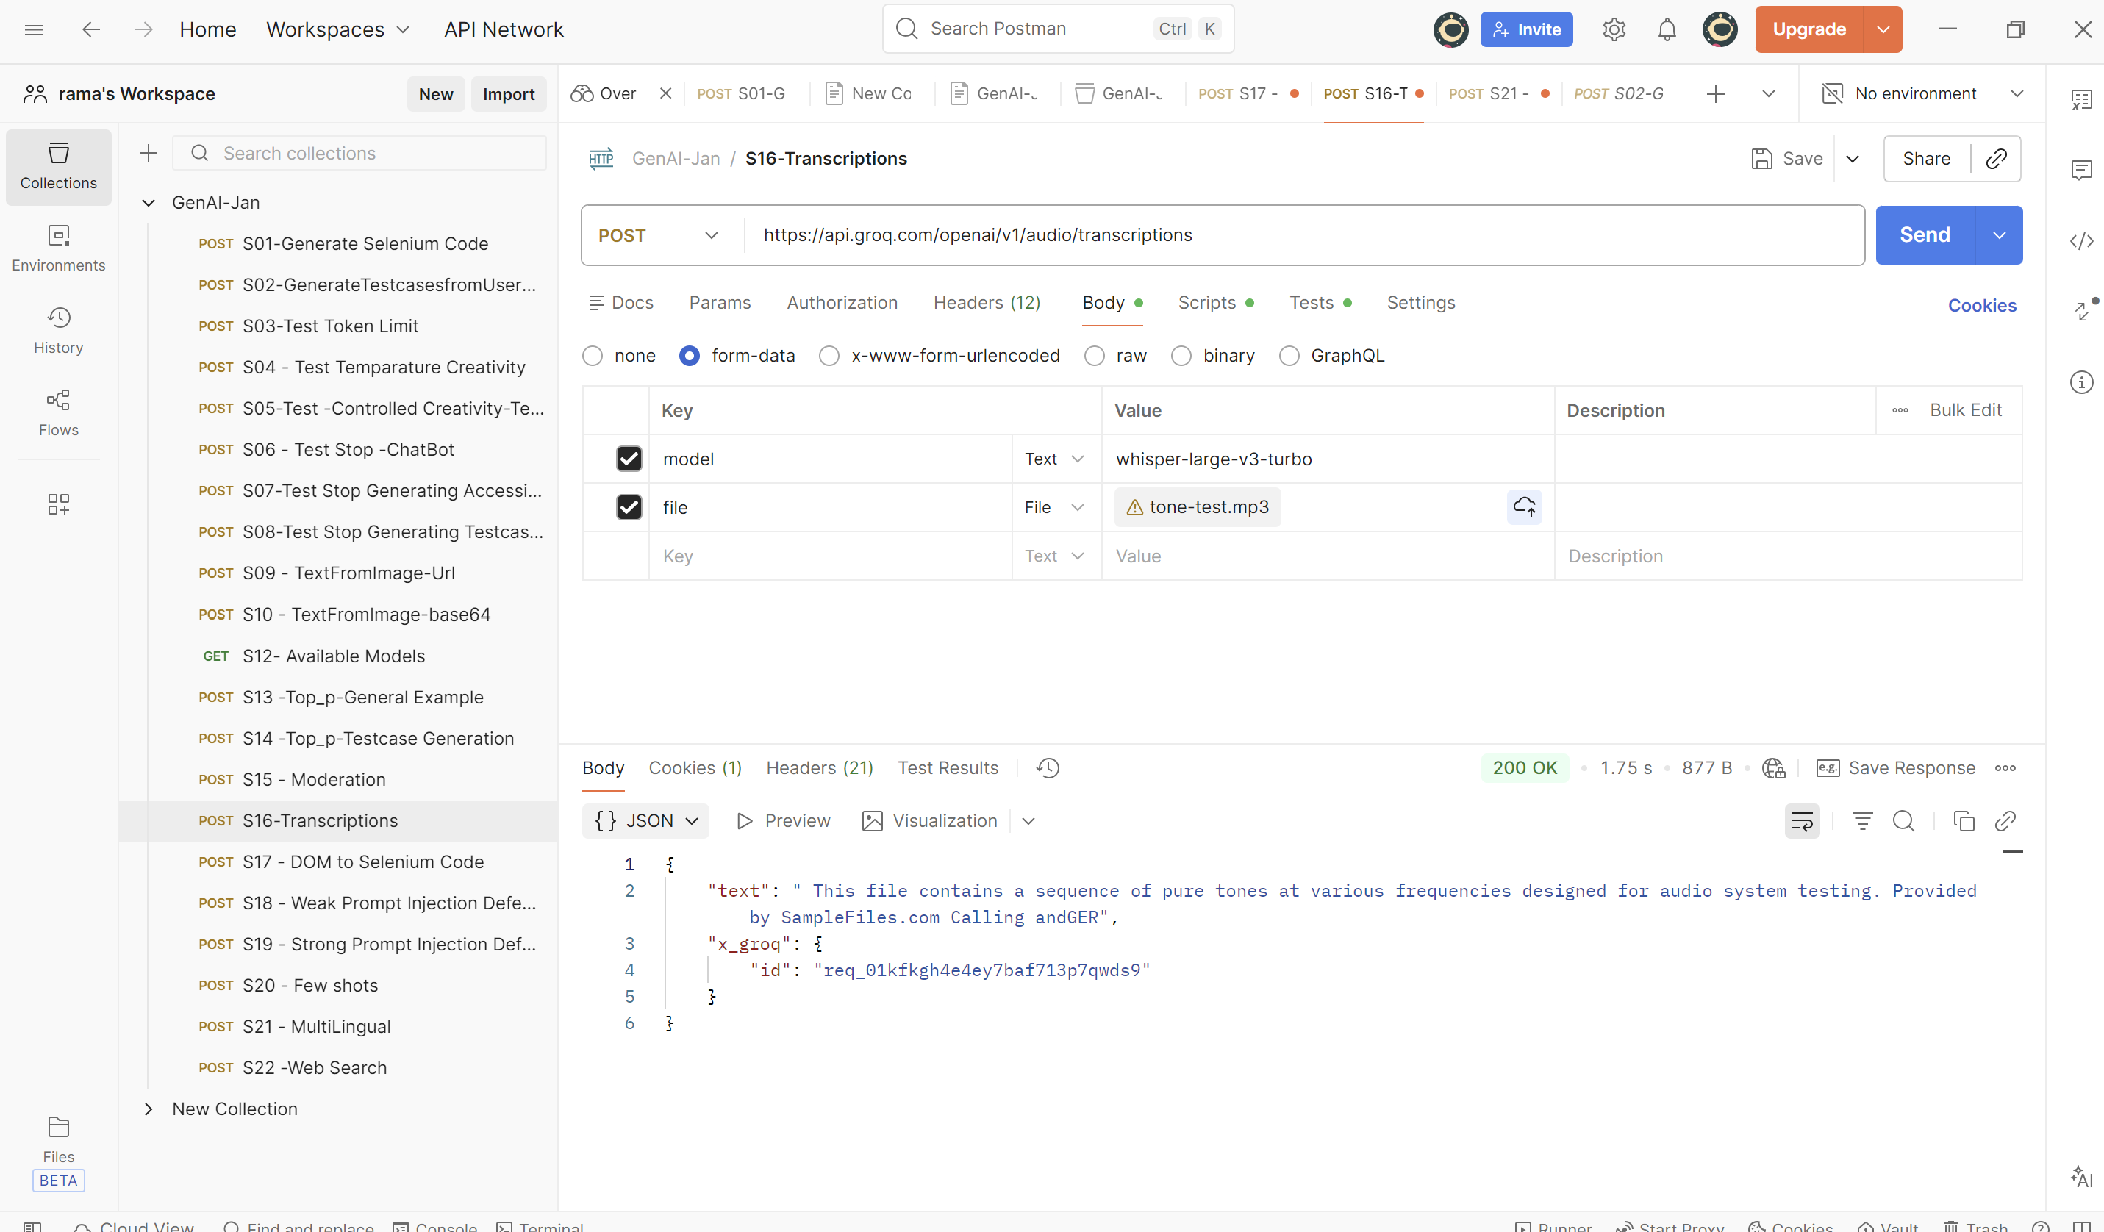

4)S09 - TextFromImage-Url
Use the vision model to extract the text from multilingual
{
"model": "meta-llama/llama-4-scout-17b-16e-instruct",
"messages": [
{
"role": "user",
"content": [
{
"type": "text",
"text": "This is a image. Extract and return only the text exactly as shown, preserving case."
},
{
"type": "image_url",
"image_url": {
"url": "https://shifu.hotstarext.com/SOURCE/VOD/cd-2025-08-29/PKLEveryday_Web-025dd6fe-6750-407c-a170-826fd089bed0.jpg"
}
}
]
}
]
}
Response:
{
"id": "chatcmpl-718acce7-03d6-4c26-a301-67d20de9a8f5",
"object": "chat.completion",
"created": 1769107746,
"model": "meta-llama/llama-4-scout-17b-16e-instruct",
"choices": [
{
"index": 0,
"message": {
"role": "assistant",
"content": "PRO KABADDI LEAGUE\nEVERY DAY\n7:30PM ONWARDS"
},
"logprobs": null,
"finish_reason": "stop"
}
],
"usage": {
"queue_time": 0.222558928,
"prompt_tokens": 2352,
"prompt_time": 0.079169912,
"completion_tokens": 21,
"completion_time": 0.053875453,
"total_tokens": 2373,
"total_time": 0.133045365
},
"usage_breakdown": null,
"system_fingerprint": "fp_79da0e0073",
"x_groq": {
"id": "req_01kfkgkvdyedkve6pdg7h5hckx",
"seed": 1849089854
},
"service_tier": "on_demand"
}

